

**Professional Bio**

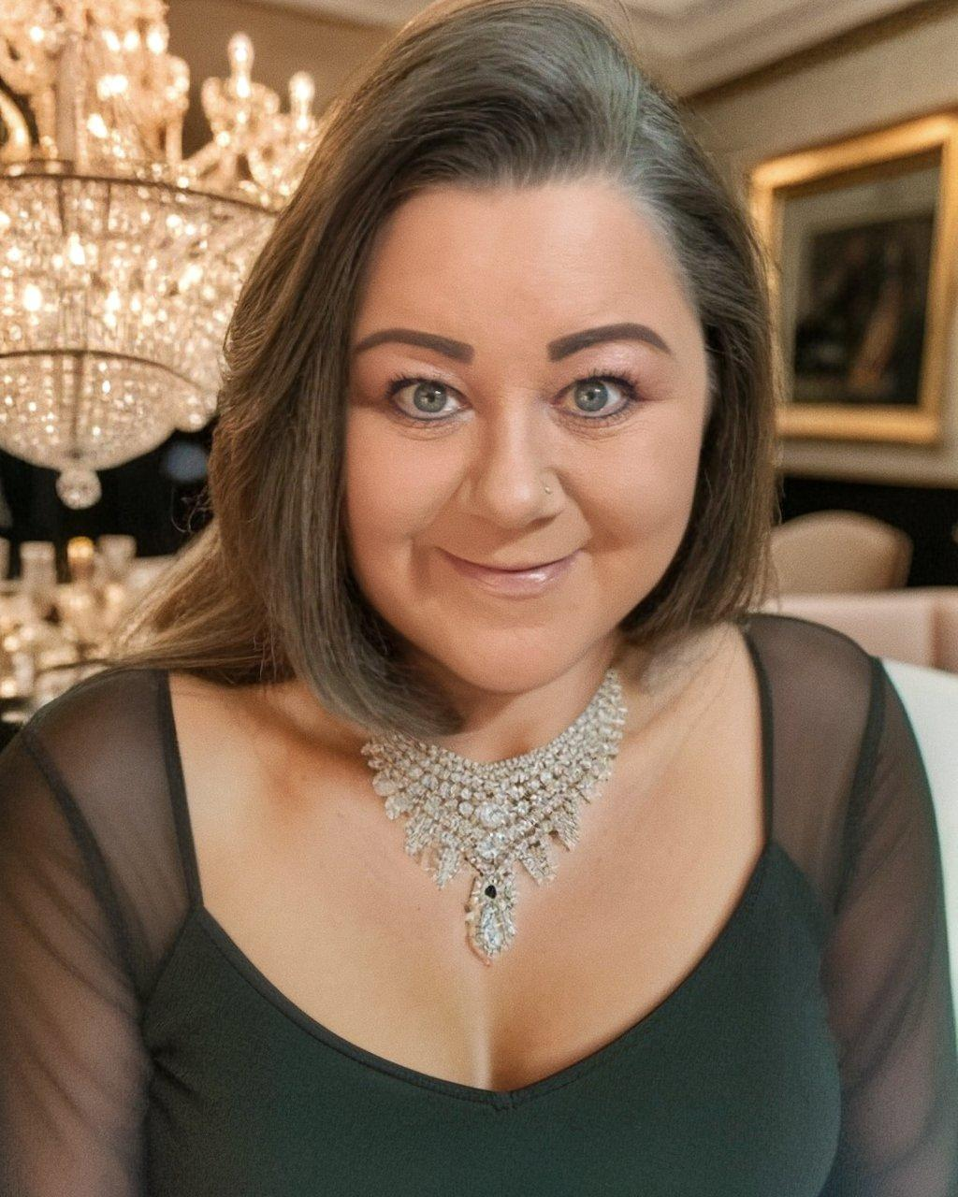

Amanda Clark is a highly sought-after success consultant, speaker, life coach and author who has inspired and helped people around the world start dreaming again – and then achieve those dreams. Best known for her unmatched passion for helping others, Amanda taps into her ability to serve as a catalyst, propelling others to action. She is a results expert, helping people to move from a point of just hoping to a point of achieving the success they desire.

As a student of self-development and human potential for nearly twenty years, Amanda uses her knowledge and experience to help others unlock their personal potential to achieve success, as well as applying it to her very own life, demonstrated by her own success story.

With a long journey of trauma healing, letting go of the past and starting a new life, Amanda has relied on her faith and unwavering belief to guide her through life’s most daunting challenges, and to ultimately achieve enviable success. In the midst of her healing journey, Amanda termed herself a “thriver” – not a mere survivor. She has applied this attitude to every aspect of her life.

Today, Amanda is a Beacon of Hope, sharing her message as a one-on-one coach and to large audiences around the world – providing support for others to achieve their life’s goals and to live as “thrivers” no matter the circumstances. Illustrated by her own experiences of finding strength and courage in the midst of tragedy, her enthusiastic message is that anyone can achieve health, happiness, and success if equipped with the right tools.

Personal Achievements

· Founder of Zenergy Healing Arts Center

· Certified Life Coach from The Coach Training Alliance

· Celebrated Business Owner and Serial Entrepreneur

· 20+ Years experience as speaker and trainer in the realm of personal growth

· Life time student in the field of self development, human potential and performance mindset

· Devoted loving mother of two beautiful children

For One Sheet, Publicity Photos, AV Requirements and more, visit: [https:/ZenergyHealingArtsCoaching.com/Speaking](http://zenergyhealingartscoaching.com/Speaking)